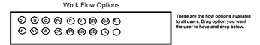
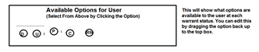
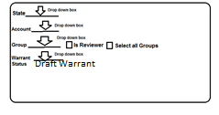
Workflow #4 Detective→Reviewer→D.A.→Judge
Warrant Status | Icons for each status
Draft Warrant | D U R PV P C
Submit for Review | RE PV P C CR
Reviewer Approved | RE PV P C D
Reviewer Rejected | D U PV P C R
Submit to D.A. | RE PV P C CD
D.A. Approved | PV P C RE
D.A. Rejected | D U R PV P C
Submit to Judge | RE C P PV CJ
Judge Approved | C PV P
Judge Rejected | PV P C A

Use Case : We need to create above Workflow #4 from UI.
Understanding :
In above workflow #4 we can see workflow contains ten different warrant status. When from UI we will create this workflow, we need to follow below steps for each ten warrant status which will be named as WorkFlow #4.
Now according to our understanding as per screen you share (Work Flow Admin.png) following steps Admin needs to perform for each warrant status.
- For “Draft Warrant” status admin will select actions icon (D U R PV P C) from first rectangle box and drop to second rectangle box. As below

- Admin will select state, account, group (detective) and status (Draft Warrant) from corresponding drop down.
- Next user will click on button. Now we have to save all information into DB.

For other Warrant Status mentioned in the Workflow #4, we need follow the same above steps for each warrant status and action icons.
Question #1 :
From above steps it’s not clear that if workflow #4 has 10steps how we will bundle all ten steps under one common name in our case i.e. Workflow #4.
We should have some mechanism so that system can identify that workflow # 4 includes ten different warrant status. Because for another workflow type the steps of action may be different.
Q1 Not may be different will be different #4 is different then #3 that is why there is a number 3.

Question #2.
If we select a Group consist of similar user type from the drop down then if we select check box “Is Reviewer” or “Select all groups”, then what will be implication. And also from the group drop down we can select only one group (each group consist of similar user type) then what is the significance of “select all group” checkbox.

Q2 Lets say there are 3 different groups 1Dictive, 2cid, 3patrol. We may want to just edit the cid group. This may mean 2 groups have 8 steps and 1 may have 10 steps.

Question #3.
We have different workflow and warrant type. So we need attach workflow to warrant type, so that when detective user will create a warrant and submit it should follow a workflow.
From which screen we can map warrant type with existing Workflow.
Q3 At this point all warrants from a group are the same workflow. Now will that change I do not know. For example a search warrant has the same WF (workflow) as a arrest warrant. (now) I do not think we need to do this.

